Project Charter: Nexus
Project Title: Agentic Client Knowledge System (Account Intelligence Layer)
Proposed By: Team Trojan Horse

1. Executive Summary
A high-level snapshot of who is doing what and when.
Role | Who | Start Date | End Date
Responsible (Owner) | Tatvic Analytics | 2026-01-19 | 2026-01-30
Data Scientist | Aryan | 2026-01-19 | 2026-01-30
AI/Backend Engineer | Khush | 2026-01-19 | 2026-01-30
Frontend/API Dev | Parshwa | 2026-01-19 | 2026-01-30
Frontend/API Dev | Saanvi | 2026-01-19 | 2026-01-30

2. Purpose

2.1 Project Background (The "Why")
Client account knowledge currently exists as "tribal knowledge," scattered across Google Drive, Gmail threads, and Chats. When team members leave or rotate, this context is lost, leading to increased onboarding time and a risk of damaging client relationships due to missing historical context. We need a system to centralize this intelligence immediately to preserve business continuity.

2.2 Project Objective (The "Goal")
Develop and deploy a functional Agentic AI MVP by January 30, 2026, that successfully ingests data from Google Mail, Chat, and Drive, and allows users to query account history with <3 second latency and 90% retrieval accuracy on tested scenarios.

2.3 Customer Benefit (The "Value")
- Account Managers: Save ~5 hours/week searching for historical contract details or decisions.
- New Joiners: Reduce account onboarding time from 2 weeks to 3 days by having a centralized "Brain" of the account.
- Leadership: Eliminate dependency on specific individuals for critical account status updates.

3. Roadmap
Breaking the 12-day sprint into critical delivery phases.
Phase | Deliverable (Output) | Critical Steps (How to get there) | Success Metrics | Deadline
Phase 1: Foundation & Pipeline | Ingestion Pipeline Prototype | 1. Setup GCP & Mongo Schema  2. Build LangGraph connectors for G-Suite  3. Implement Text Preprocessing | Data flowing from Source to DB | Jan 23
Phase 2: Intelligence & UI | Functional Dashboard | 1. Develop RAG Architecture (Gemini + Chroma)  2. Build React Frontend with Tailwind  3. Connect FastAPI endpoints | UI renders answers from Chroma | Jan 28
Phase 3: Integration & Release | Deployed MVP | 1. Integration Testing  2. User Acceptance Demo  3. Handover Documentation | System Live on Staging | Jan 30

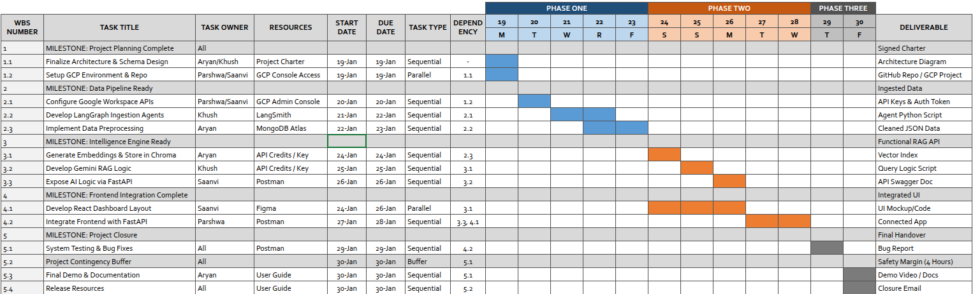

4. Project Details

4.1 Scope (In vs. Out)g
In Scope (MVP):
- Data Sources: Google Mail, Google Chat, Google Drive, User Input.
- Functionality:
  - Data ingestion and preprocessing pipeline.
  - RAG-based Query Engine (Gemini + Chroma DB).
  - Web Dashboard (React) for querying and viewing account insights.
  - Role-based visibility (Basic Commercial vs. General distinction).
- Users: Internal Tatvic Account Teams.
Out of Scope (Phase 2):
- Integration with Basecamp, Jira, or Client-owned tools.
- Write-back functionality (Agent sending emails).
- Mobile Application.

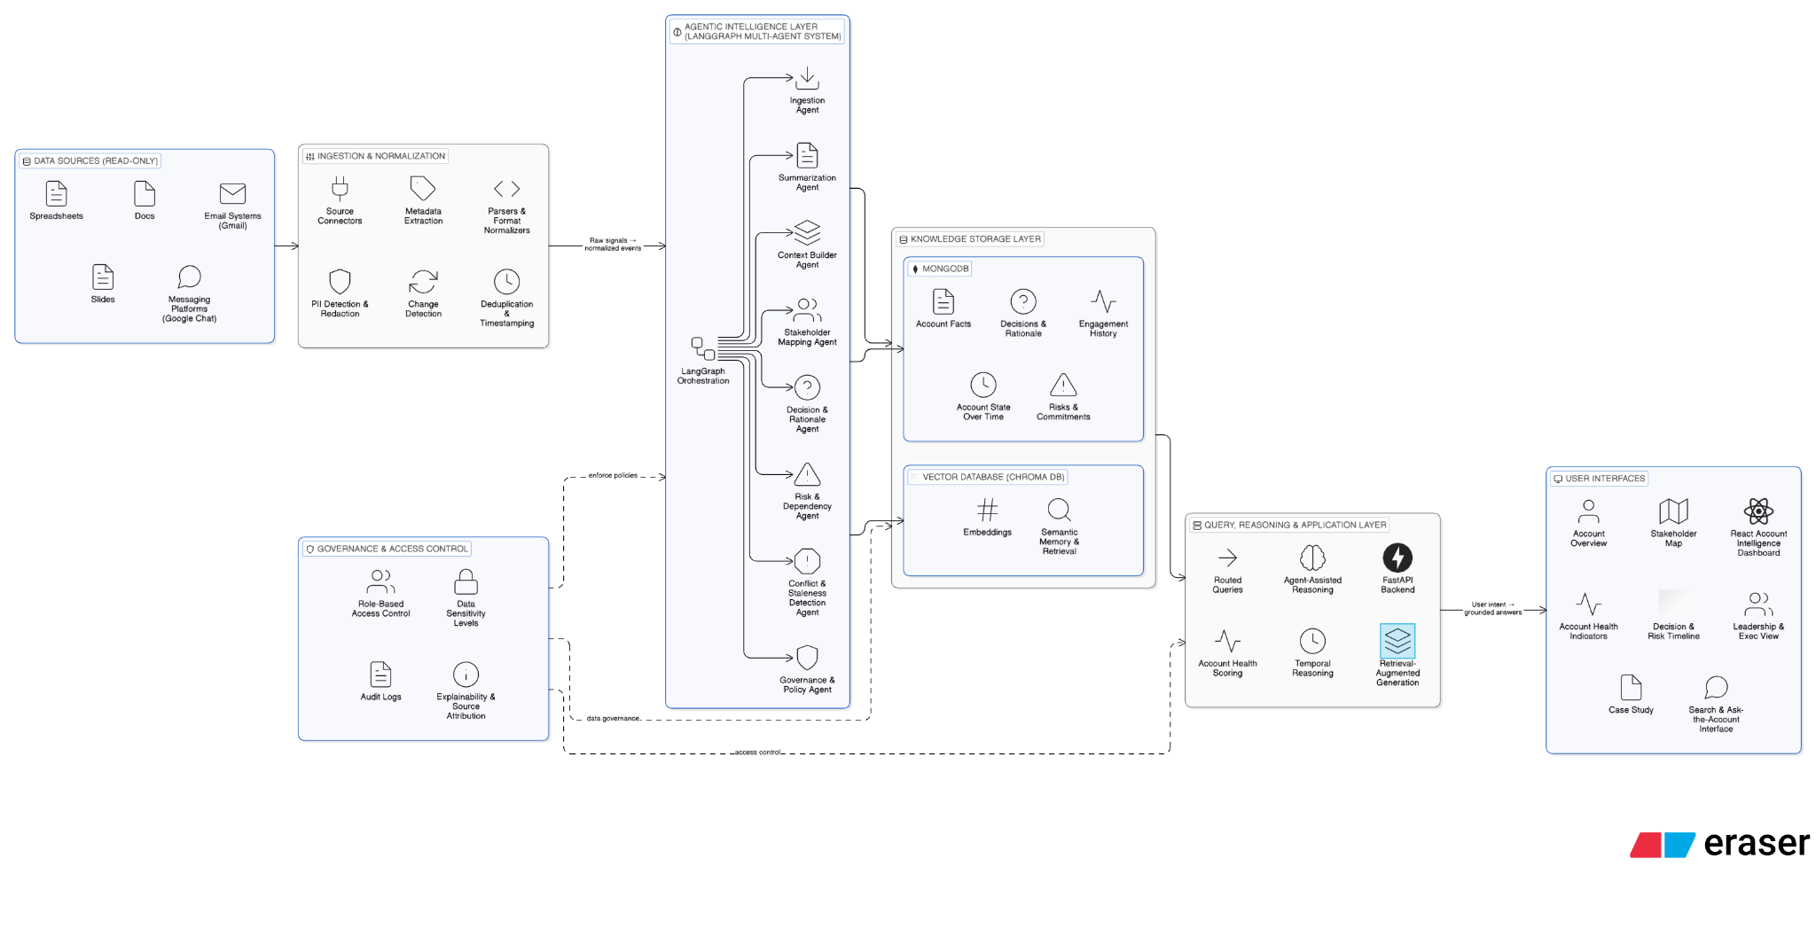

4.2 Budget
Total Estimated Budget: ₹55,000 INR
- Labor (Internal Cost Allocation): ₹25,000 INR
  - Calculation based on 4 FTEs x 10 days x Avg Day Rate.
- Infrastructure (GCP, Gemini API, Mongo Atlas): ₹25,000 INR
- Contingency Buffer (10%): ₹5,000 INR

4.3 Resources & RACI Matrix
Team & Tech Stack:
- People: 4 Team Members (Full-time allocation).
- Tech Stack: LangGraph, LangChain, Gemini Pro, Chroma DB, React, Tailwind CSS, Google Cloud Platform (GCP), MongoDB, FastAPI.
- Tools: Figma, GitHub (Version Control), LangSmith, PostMan.
RACI Chart (Roles & Responsibilities):
- R = Responsible (Doer), A = Accountable (Owner), C = Consulted, I = Informed
Activity | Tatvic (Owner) | Aryan (Data Sci) | Khush (AI Eng) | Parshwa (FE/API) | Saanvi (FE/API)
Project Charter | A | R | R | R | R
Data Ingestion | I | A/R | C | C | I
AI/RAG Dev | I | C | A/R | I | I
API Dev | I | I | C | R | R
Frontend UI | I | I | I | R | A/R
Integration | A | R | R | R | R
Final Sign-off | A | I | I | I | I

4.4 Time and Effort Estimation
Role | Phase 1: Foundation(Jan 19 - Jan 23) | Phase 2: Intelligence(Jan 24 - Jan 28) | Phase 3: Closure(Jan 29 - Jan 30) | Total Hours
Data Scientist | 24h | 8h | 16h | 48h
AI Engineer | 24h | 8h | 8h | 40h
Full Stack Devs | 16h | 48h | 16h | 80h
Project Lead | 4h | 0h | 4h | 8h
Total Effort | 68 Hours | 64 Hours | 44 Hours | 176 Hours
Phase Duration | 5 Days | 5 Days | 2 Days | 12 Days

4.4 Risks
Risk | Impact | Mitigation Strategy
API Rate Limits: Google API quotas may slow down initial data ingestion. | High | Implement exponential backoff in LangGraph and cache data in MongoDB to minimize redundant calls.
Hallucination: Gemini might generate incorrect client summaries. | High | Implement "Grounding" by forcing the model to cite specific document IDs (Source Attribution) in the response.
Tight Timeline: 12 days is very short for a full RAG system. | Critical | Scope is strictly limited to Google ecosystem. Descope "Chat History" if Gmail ingestion takes too long. Daily standups to track slippage.
Data Privacy: Leaking sensitive client PII to the LLM. | High | Anonymize PII (Personal Identifiable Information) in the preprocessing stage before sending to embedding API.

4.5 Final Success Measurement
The project is closed when:
- The system ingests emails and drive docs from a sample account.
- A user can ask "What was the last decision regarding the X Contract?" and receive a correct, sourced answer in the Dashboard.
- Source code is pushed to the repository with a README.md.

4.6 Future Plans & Sustainability
- Post-Launch: The DevOps team will monitor API costs weekly.
- Phase 2: Integrate Basecamp and Jira (Scheduled for Q2 2026).
- Maintenance: Bi-weekly re-indexing of the vector database to ensure new emails are captured.

5. Detailed Work Breakdown Structure (WBS)
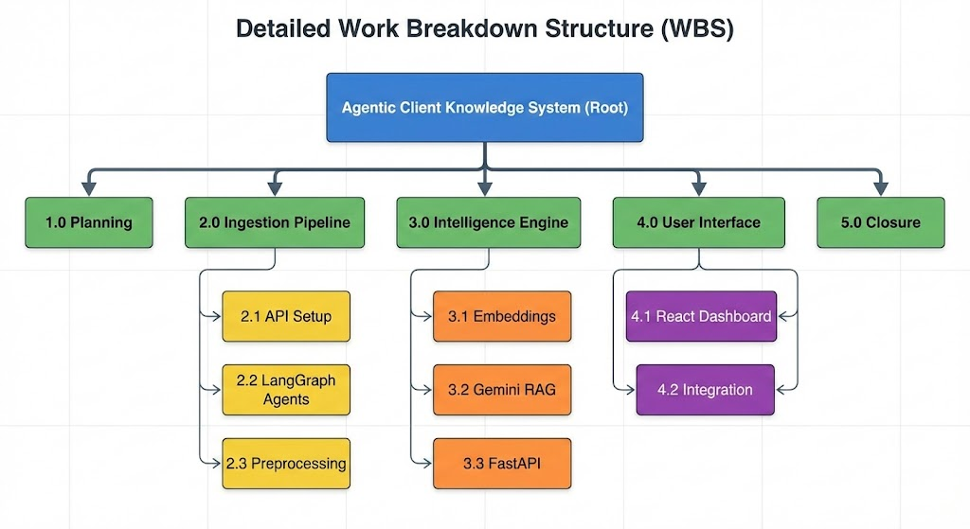

WBS ID | Task/Milestone Name | Task Type | Dependency | Responsible | Start Date | End Date | Deliverable
1.0 | MILESTONE: Project Planning Complete (CP) | Sequential | - | Tatvic | 2026-01-19 | 2026-01-19 | Signed Charter
1.1 | Finalize Architecture & Schema Design (CP) | Sequential | - | Aryan/Khush | 2026-01-19 | 2026-01-19 | Architecture Diagram
1.2 | Setup GCP Environment & Repo (CP) | Parallel | 1.1 | Parshwa | 2026-01-19 | 2026-01-19 | GitHub Repo / GCP Project
2.0 | MILESTONE: Data Pipeline Ready (CP) | Sequential | 1.2 | Aryan | 2026-01-20 | 2026-01-23 | Ingested Data
2.1 | Configure Google Workspace APIs (CP) | Sequential | 1.2 | Parshwa | 2026-01-20 | 2026-01-20 | API Keys & Auth Token
2.2 | Develop LangGraph Ingestion Agents (CP) | Sequential | 2.1 | Khush | 2026-01-21 | 2026-01-22 | Agent Python Script
2.3 | Implement Data Preprocessing (Clean/Chunk) (CP) | Sequential | 2.2 | Aryan | 2026-01-22 | 2026-01-23 | Cleaned JSON Data
3.0 | MILESTONE: Intelligence Engine Ready (CP) | Sequential | 2.3 | Khush | 2026-01-24 | 2026-01-26 | Functional RAG API
3.1 | Generate Embeddings & Store in Chroma (CP) | Sequential | 2.3 | Aryan | 2026-01-24 | 2026-01-24 | Vector Index
3.2 | Develop Gemini RAG Logic (Langvahin/Chain) (CP) | Sequential | 3.1 | Khush | 2026-01-25 | 2026-01-25 | Query Logic Script
3.3 | Expose AI Logic via FastAPI (CP) | Sequential | 3.2 | Saanvi | 2026-01-26 | 2026-01-26 | API Swagger Doc
4.0 | MILESTONE: Frontend Integration Complete (CP) | Sequential | 3.3 | Parshwa | 2026-01-24 | 2026-01-28 | Integrated UI
4.1 | Develop React Dashboard Layout (Tailwind) | Parallel | 3.1 | Saanvi | 2026-01-24 | 2026-01-26 | UI Mockup/Code
4.2 | Integrate Frontend with FastAPI (CP) | Sequential | 3.3, 4.1 | Parshwa | 2026-01-27 | 2026-01-28 | Connected App
5.0 | MILESTONE: Project Closure (CP) | Sequential | 4.2 | Tatvic | 2026-01-29 | 2026-01-30 | Final Handover
5.1 | System Testing & Bug Fixes (CP) | Sequential | 4.2 | All | 2026-01-29 | 2026-01-29 | Bug Report
5.2 | Project Contingency Buffer | Buffer | 5.1 | Owner | 2026-01-30 | 2026-01-30 | Safety Margin (4 Hours)
5.3 | Final Demo & Documentation | Sequential | 5.2 | Aryan | 2026-01-30 | 2026-01-30 | Demo Video / Docs
5.4 | Release Resources | Sequential | 5.3 | Owner | 2026-01-30 | 2026-01-30 | Closure Email

6. Critical Task Table

WBS ID | Critical Task Name | Owner | Deadline | Why is it Critical?
1.1 | Finalize Architecture | Aryan | Jan 19 | Blocks all development; schema must be defined first.
2.1 | Configure APIs | Parshwa | Jan 20 | Blocks the ingestion agents; no data access without keys.
2.2 | Develop LangGraph Agents | Khush | Jan 22 | The most complex single backend task (2 days).
2.3 | Data Preprocessing | Aryan | Jan 23 | Embeddings (3.1) cannot be generated on dirty data.
3.1 | Generate Embeddings | Aryan | Jan 24 | Risk: Scheduled on a Saturday. Blocks RAG logic.
3.2 | Gemini RAG Logic | Khush | Jan 25 | Risk: Scheduled on a Sunday. Core intelligence layer.
3.3 | Expose FastAPI | Saanvi | Jan 26 | The Frontend team cannot integrate (4.2) without this.
4.2 | Integrate UI with API | Parshwa | Jan 28 | The bottleneck where Backend and Frontend merge.
5.1 | System Testing | All | Jan 29 | Final check. Any bugs found here directly impact launch.

